Assignment 3.3 AI ASSISTED CODING

Htno:2303a51983

Btno:06

Task 1: AI-Generated Logic for Reading Consumer Details .

Prompt:

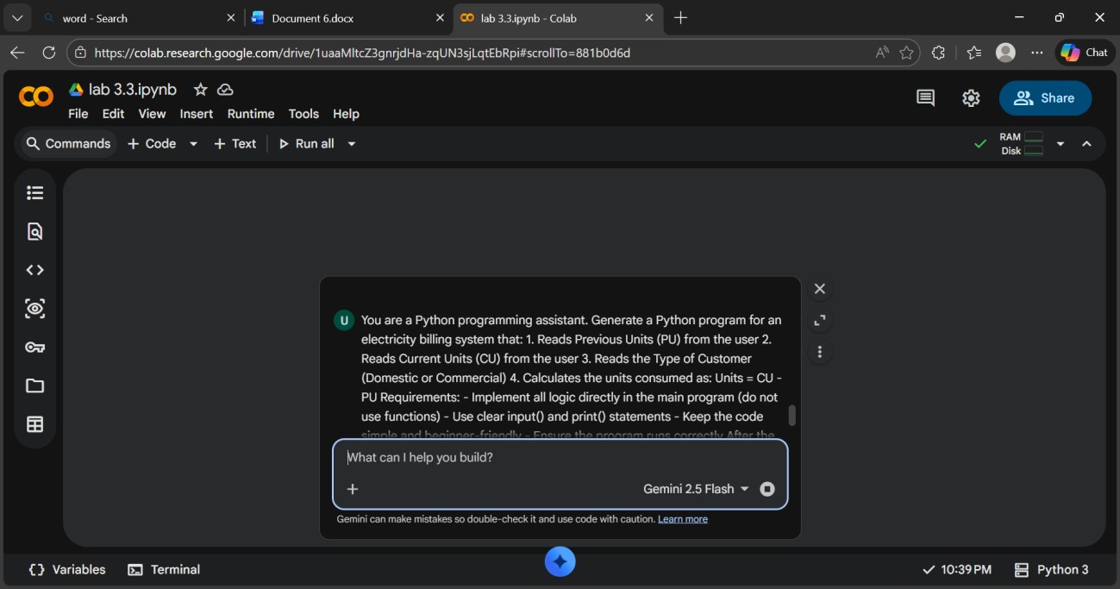

Code:

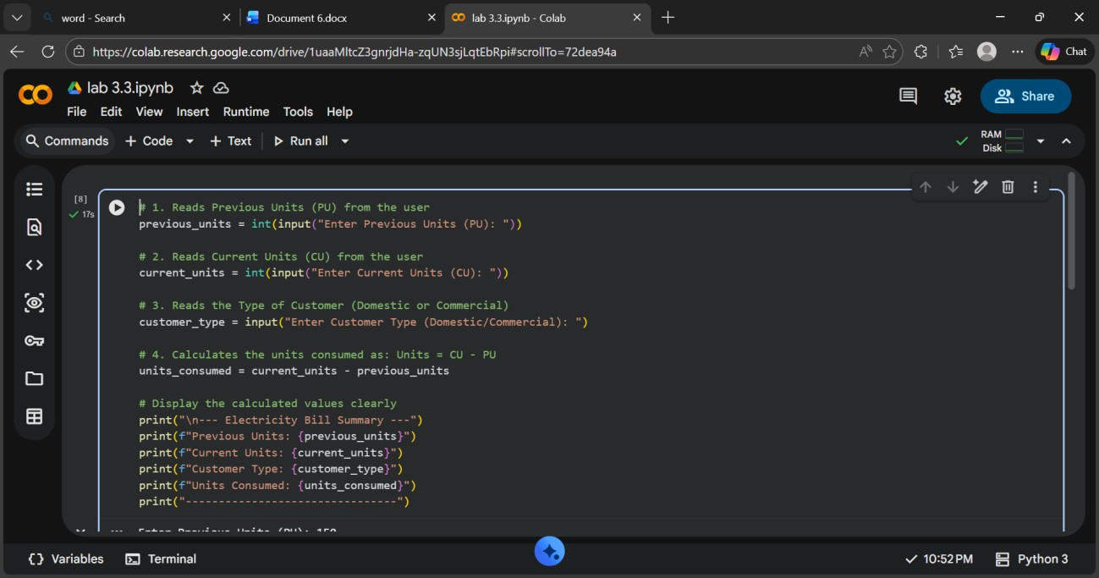

Output:

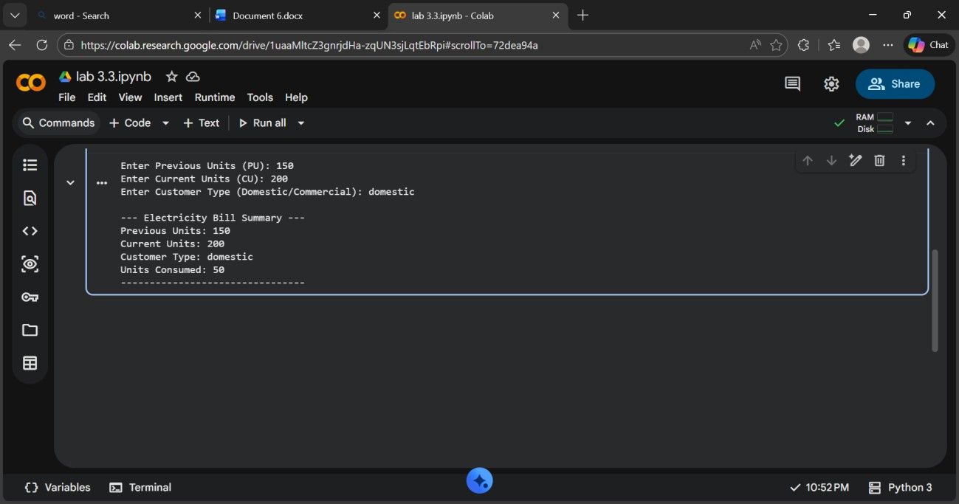

Explanation: The program reads previous units, current units, and customer type from the user.

It calculates **units consumed** by subtracting previous units from current units (200 − 150 = 50).

Finally, it displays a clear electricity bill summary with all entered details and the calculated consumption.

Task 2: Energy Charges Calculation Based on Units Consumed.

Prompt:

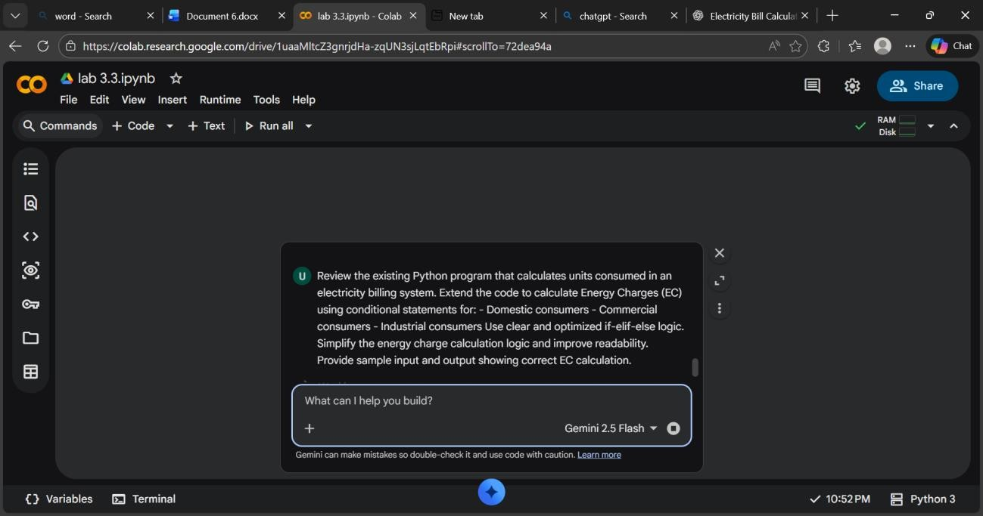

Code:

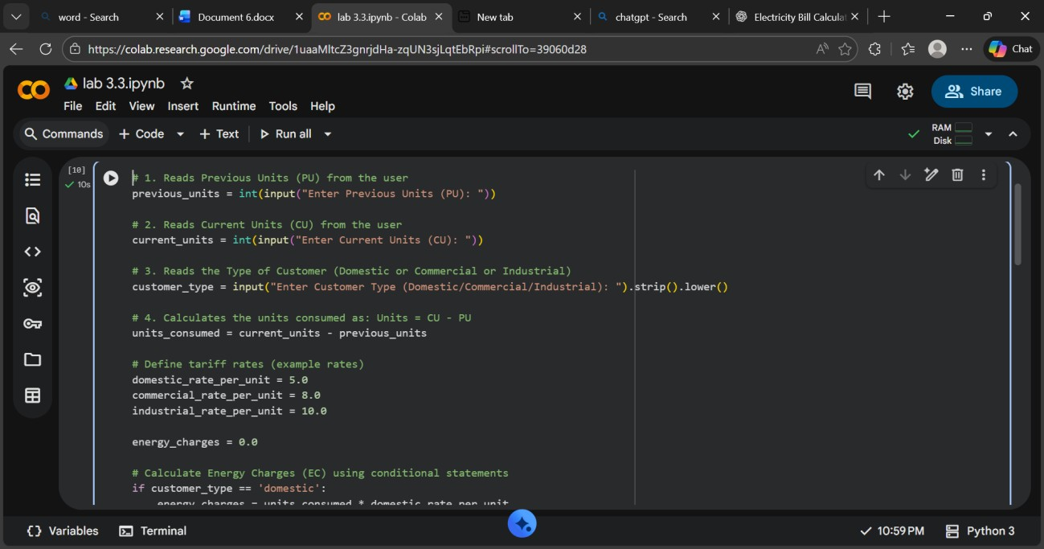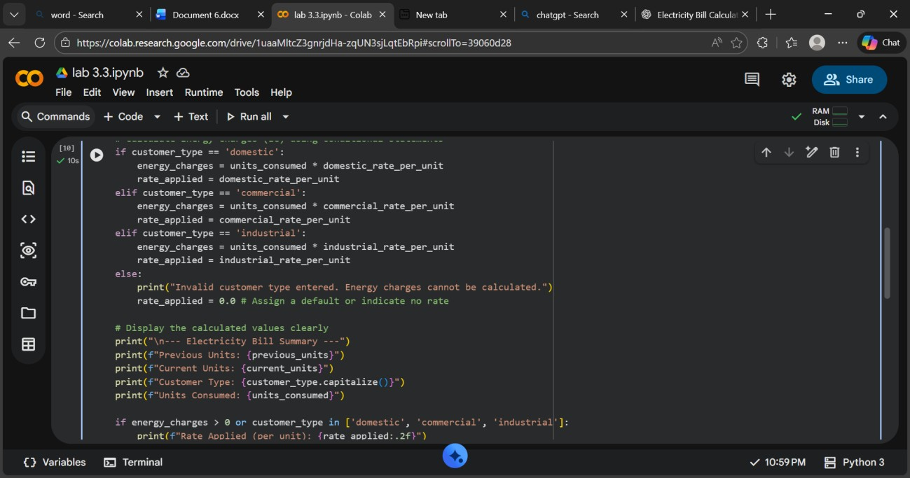

Output:

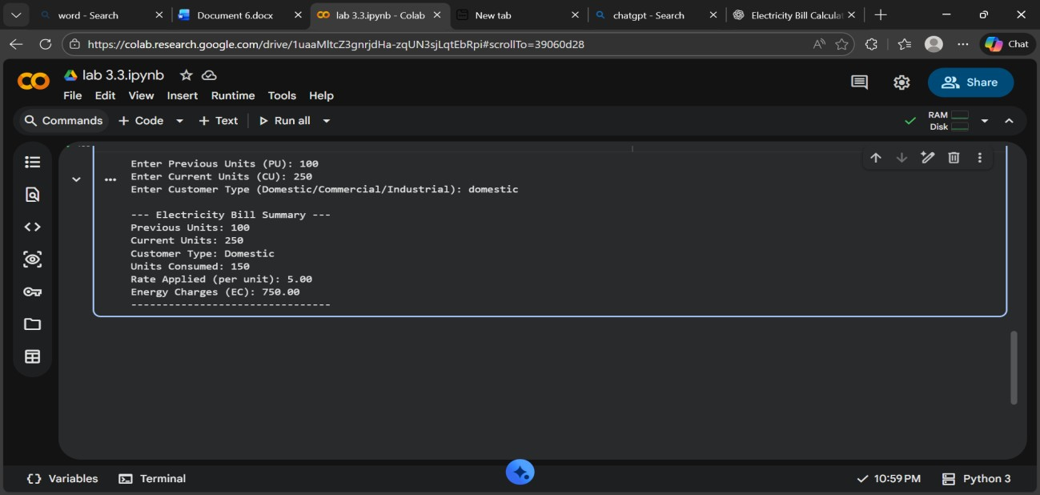

Expalantion: The extended program calculates **Energy Charges** based on units consumed and customer type using conditional statements.

Optimized if-elif-else logic improves readability and makes the billing rules easy to understand.

Task 3: Modular Design Using AI Assistance (Using Functions).

Prompt:

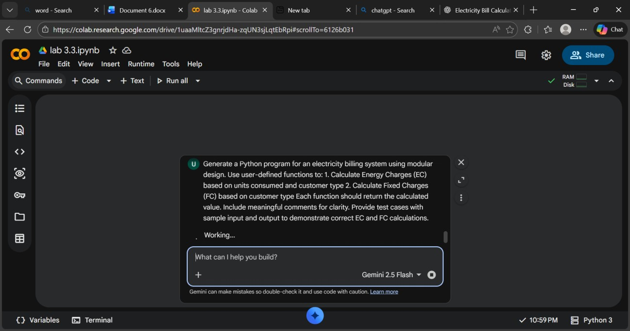

Code:

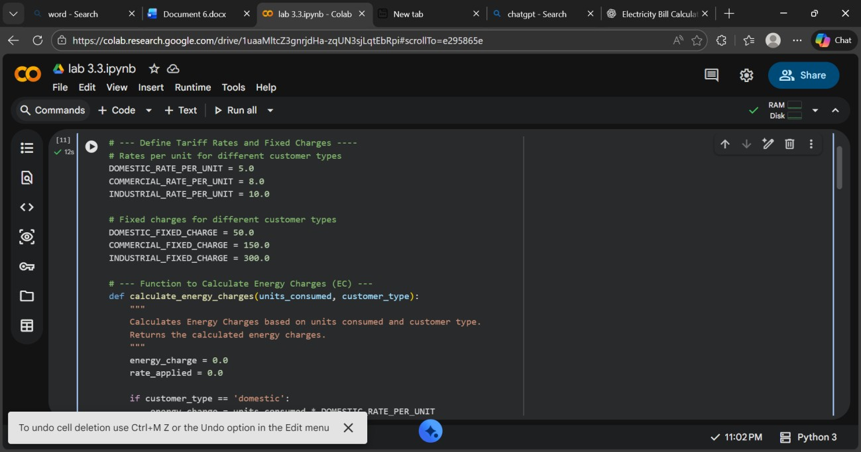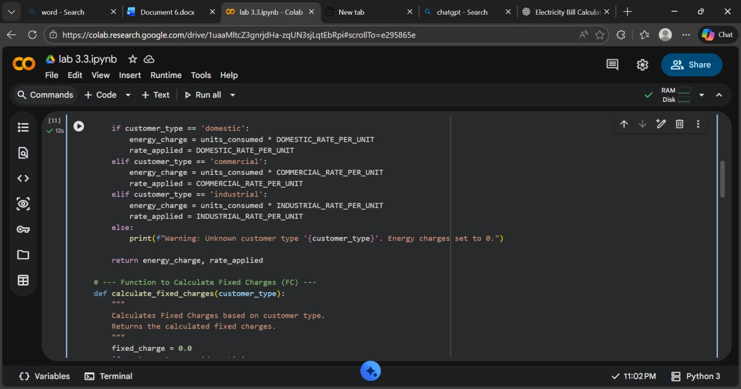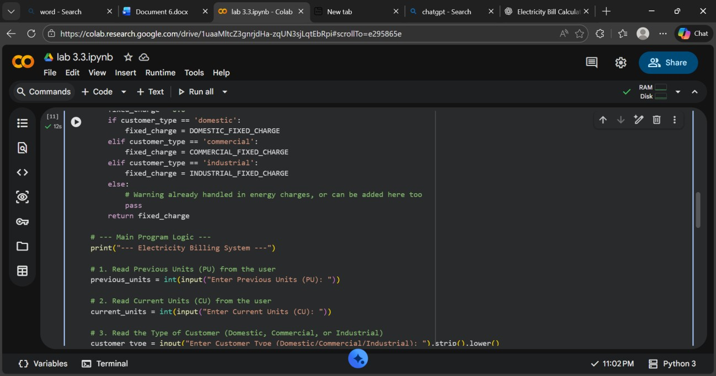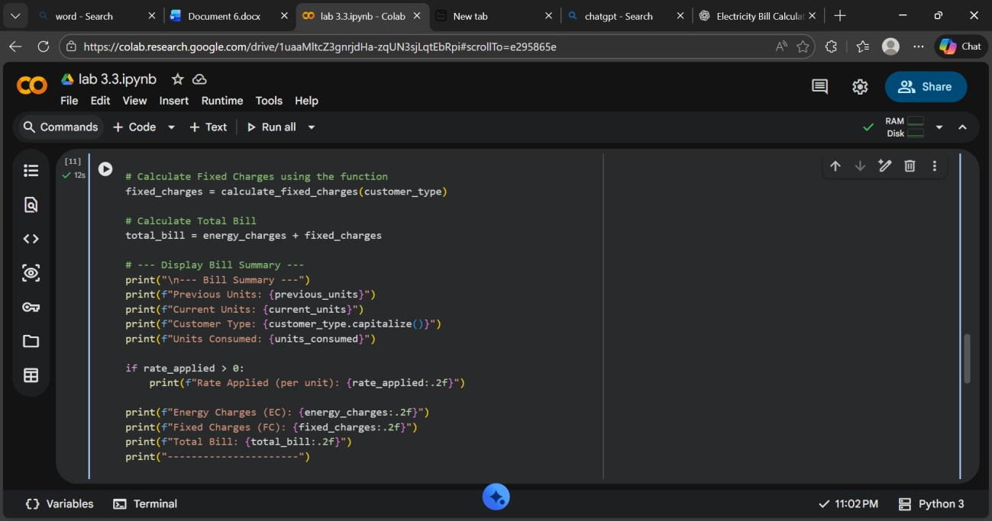

Output:

Explanation: This program uses **functions** to make the billing logic reusable for multiple consumers.

Separating Energy Charges and Fixed Charges into functions improves clarity, modularity, and easy maintenance of the code.

Task 4: Calculation of Additional Charges.

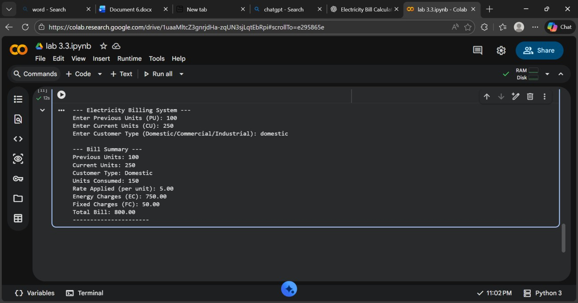Prompt:

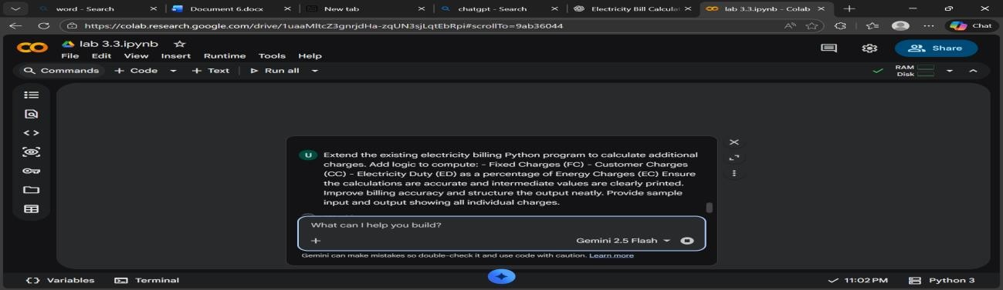

Code:

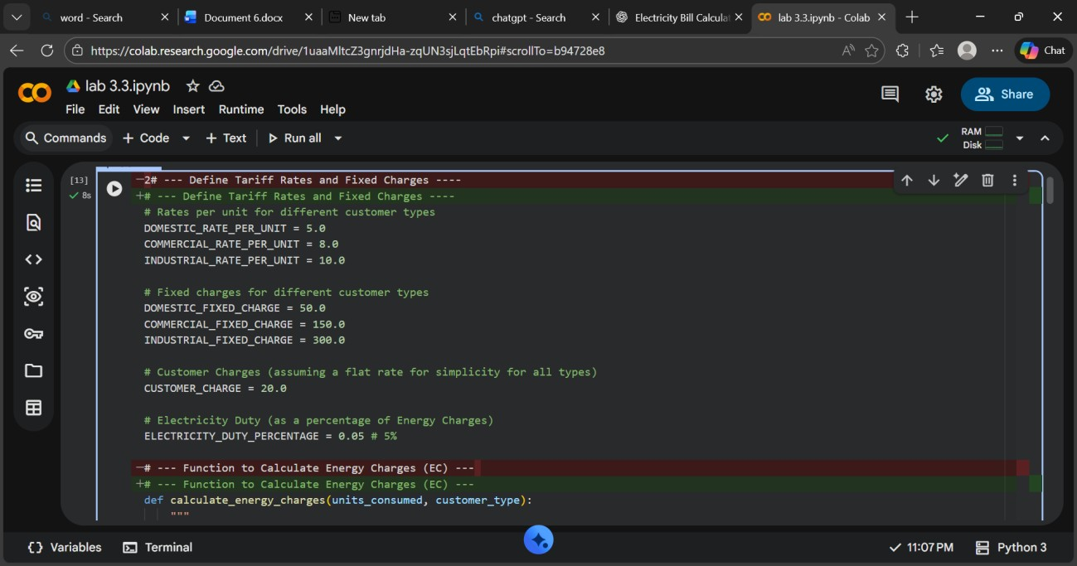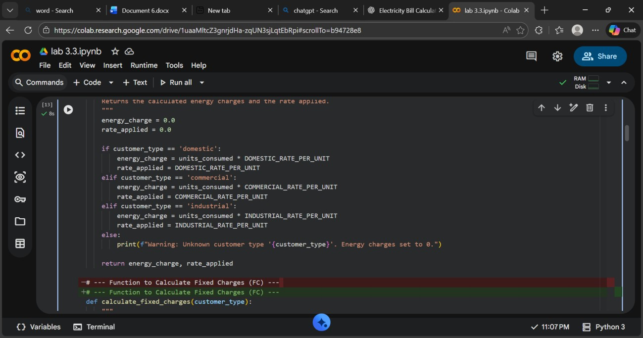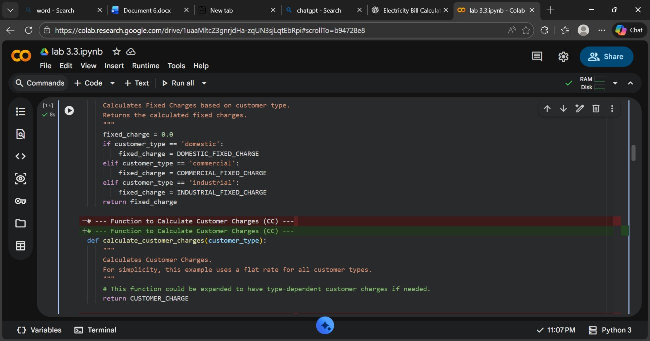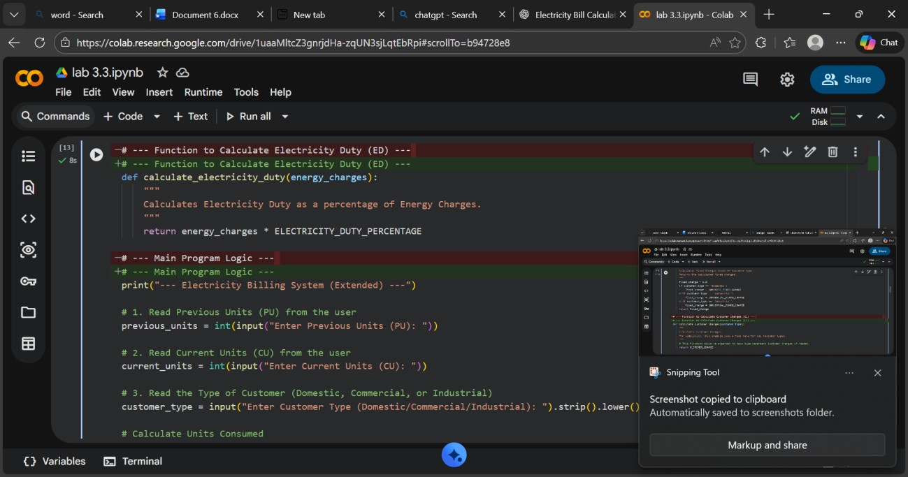

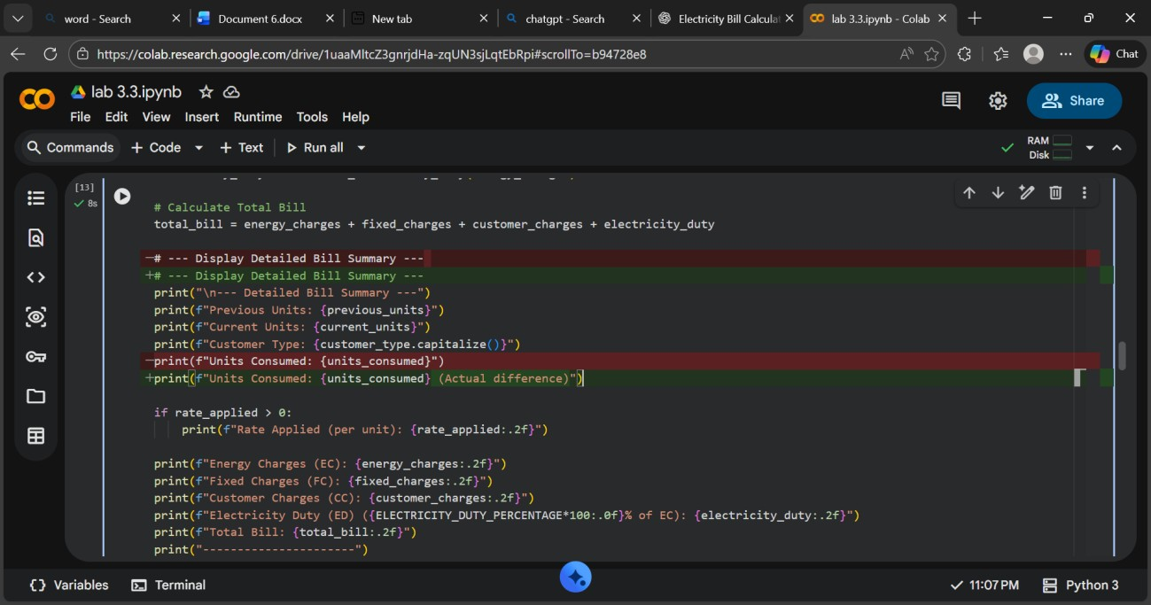

Output:

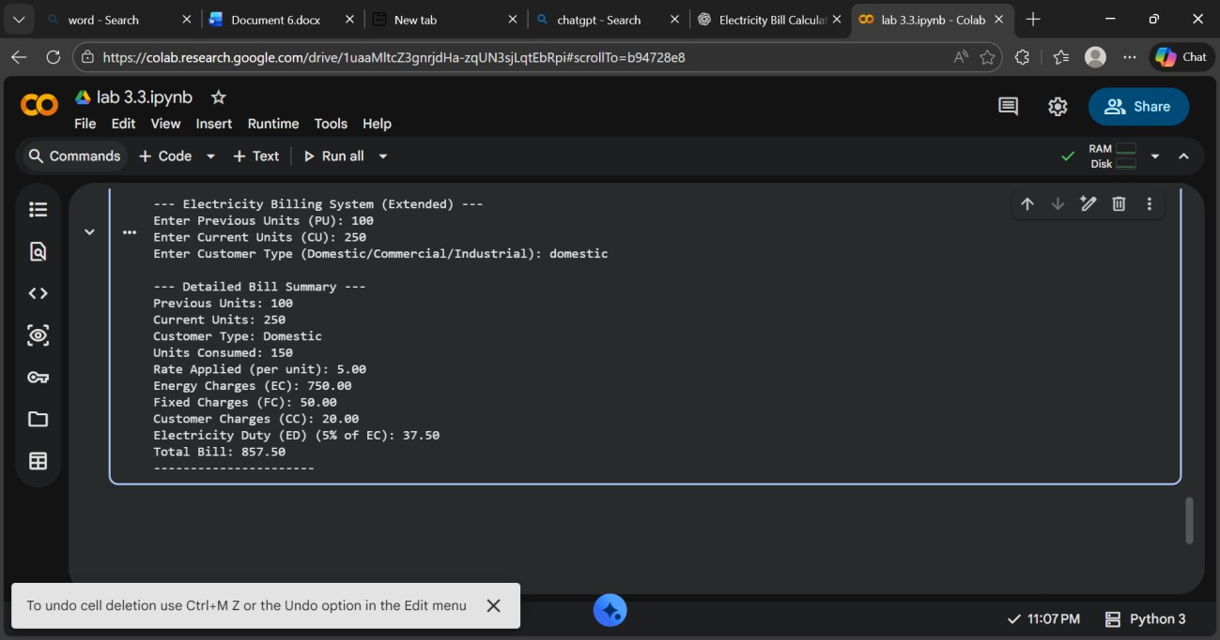

Explanation: The program is enhanced to include **additional billing components** like fixed charges, customer charges, and electricity duty.

Electricity Duty is calculated as a **percentage of Energy Charges**, and all values are displayed clearly for verification.

Task 5: Final Bill Generation and Output Analysis.

Prompt:

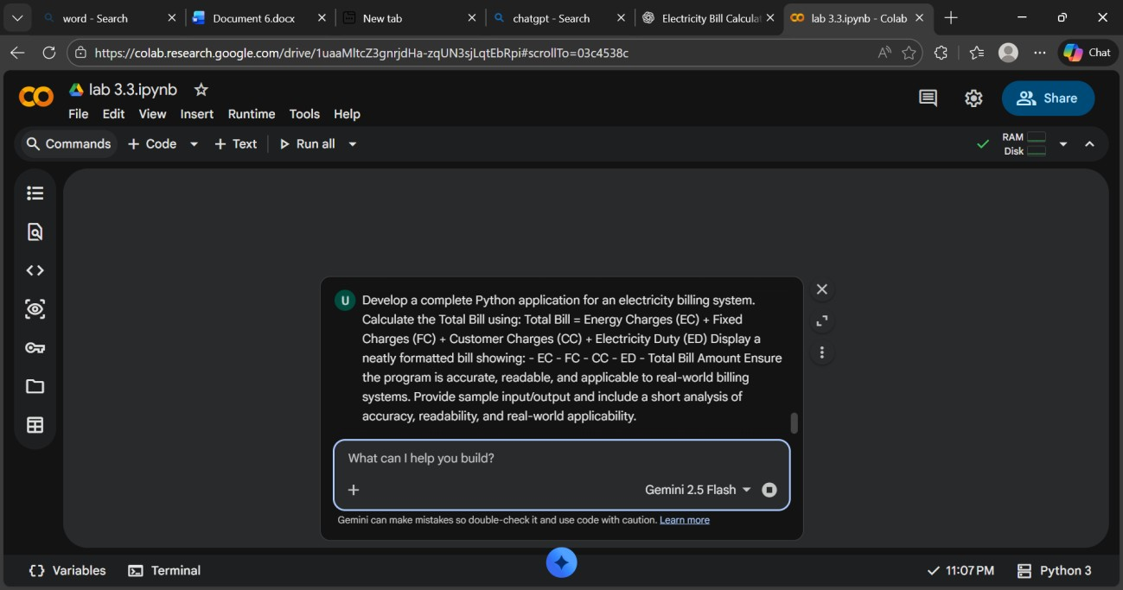

Code:

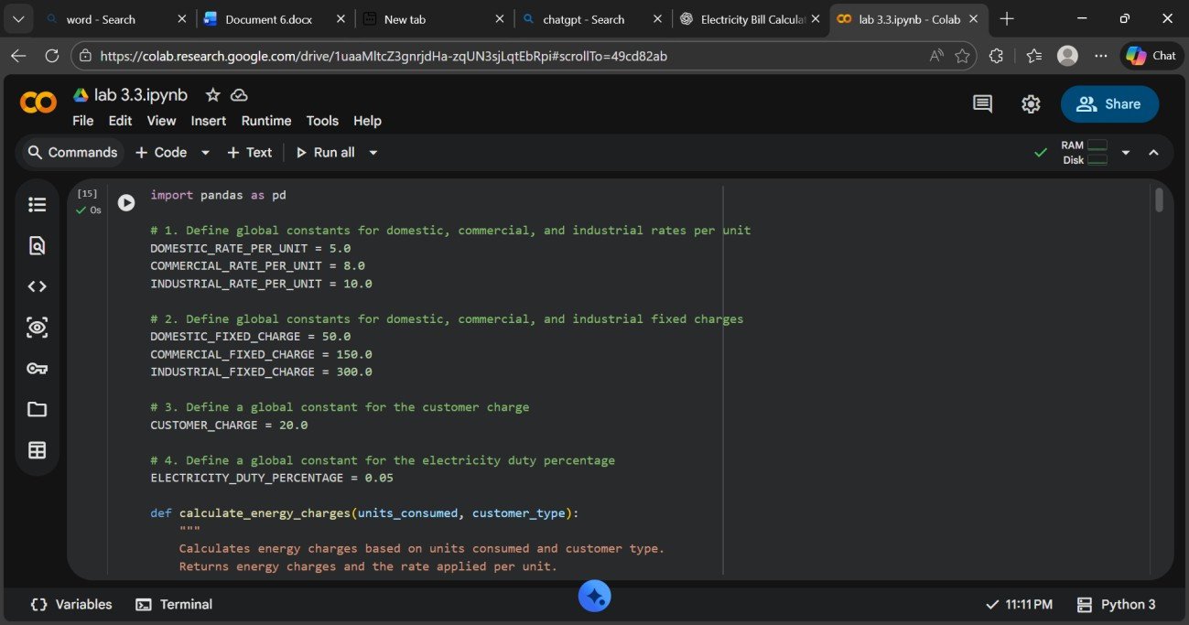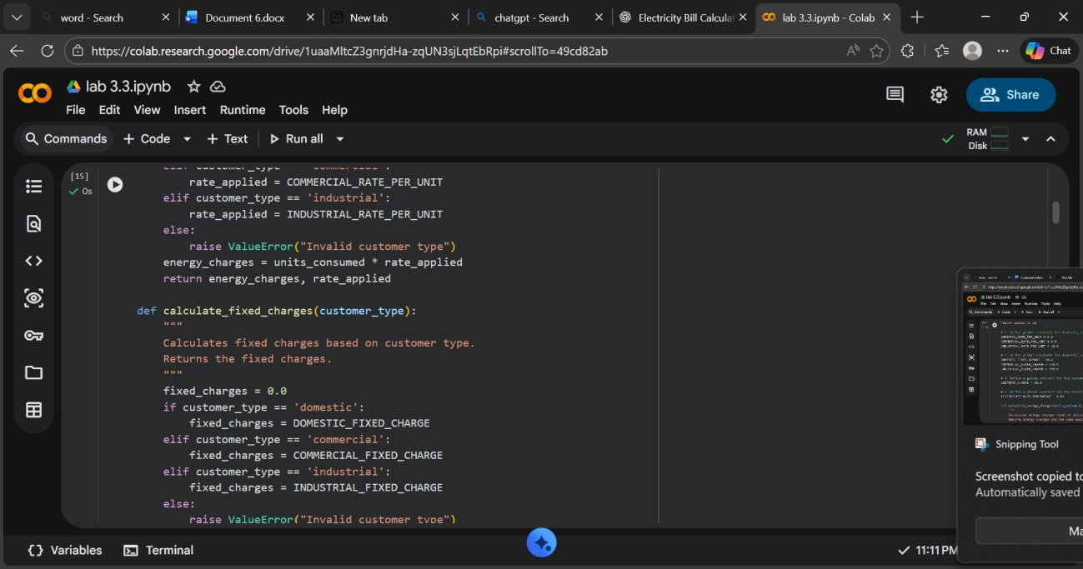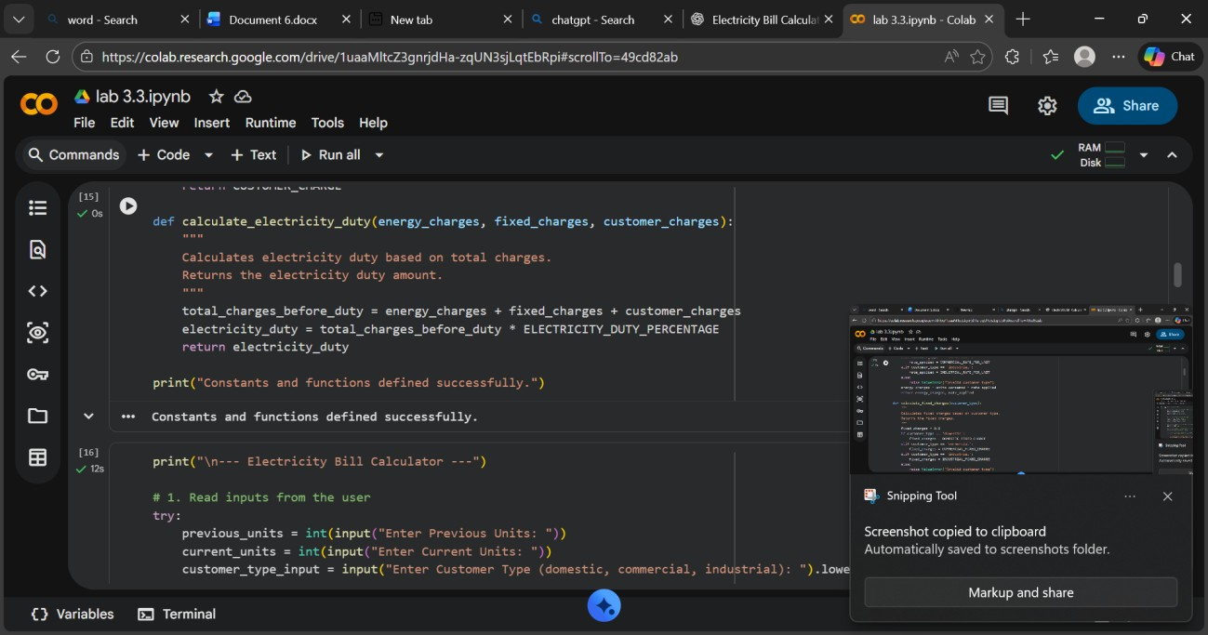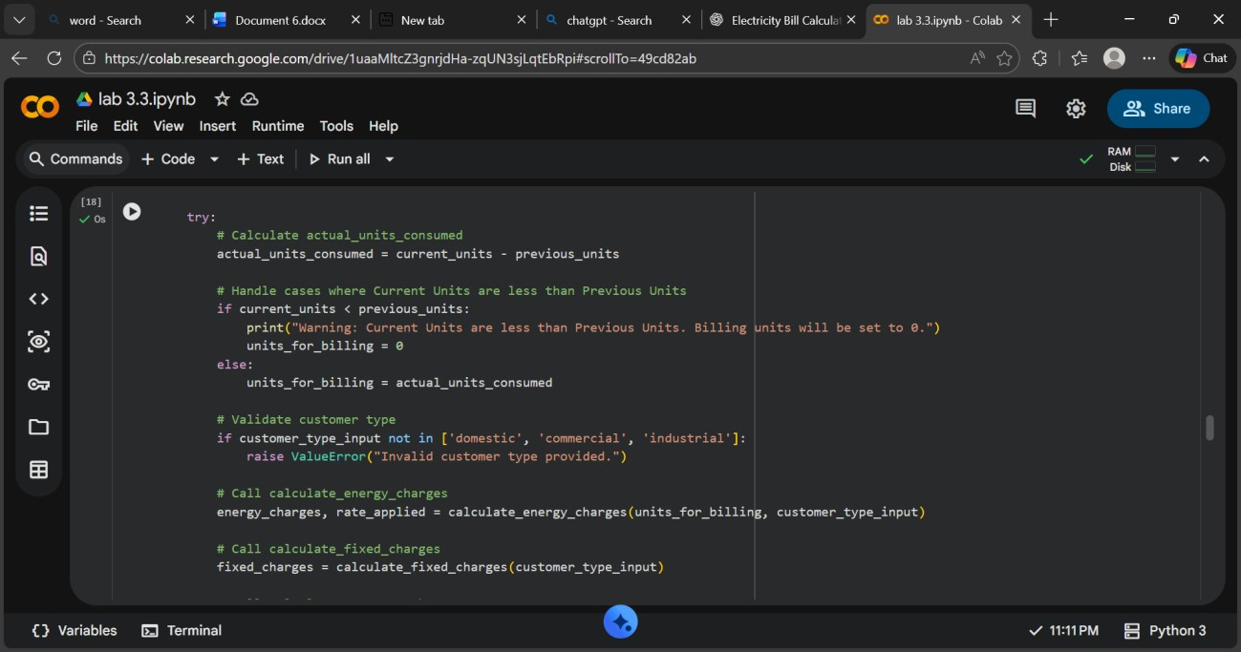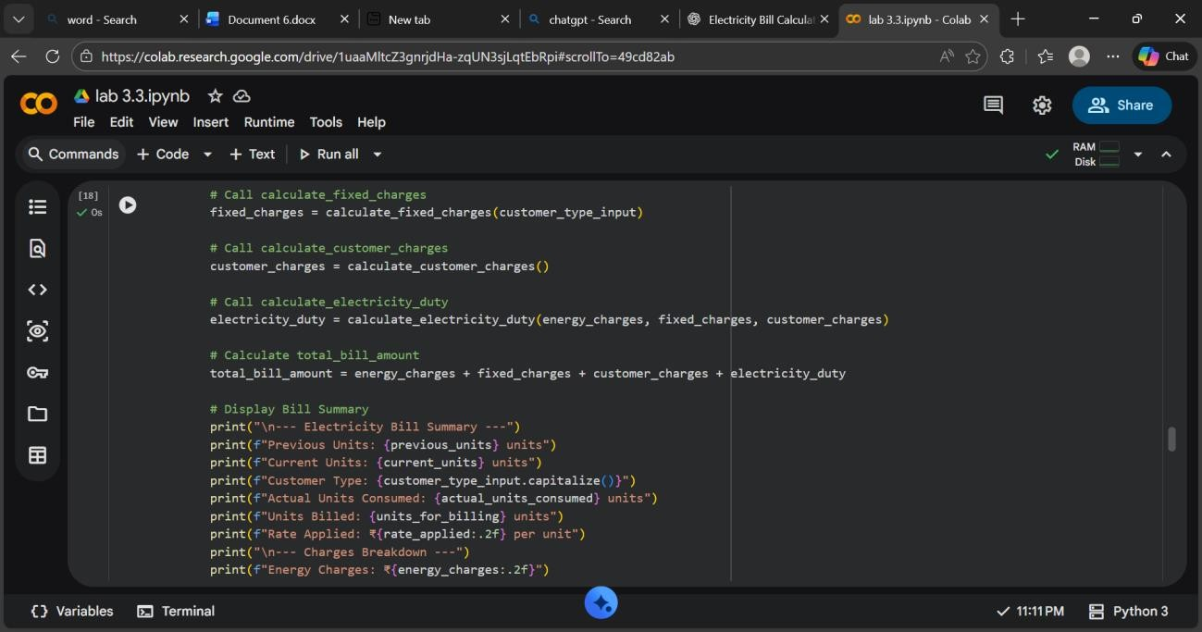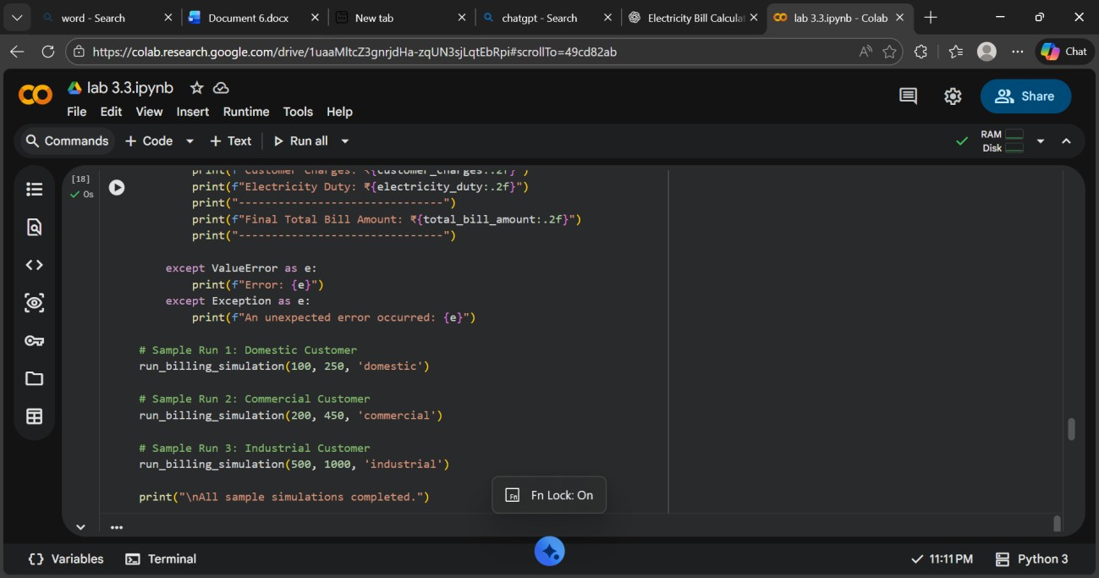

Output:

Explanation: he final program accurately computes all billing components and presents them in a clear, structured format.

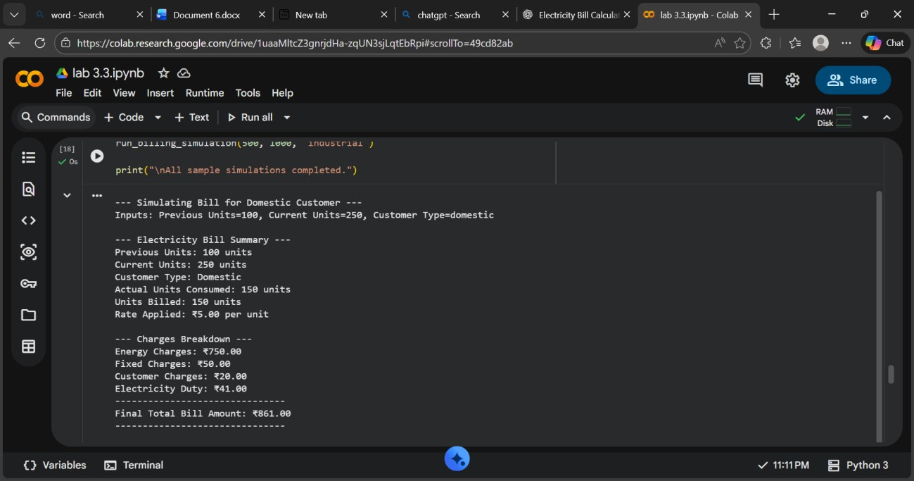 Its readable logic and modular design make it suitable for real-world electricity billing applications and easy future enhancements.